PURPOSE:

This Operation and Maintenance (O&M) manual describes the procedures for the operation and maintenance of the BioTechne ProteinSimple Maurice device.

SCOPE:

This O&M applies to all qualified personnel performing GMP-related analytical testing using the BioTechne ProteinSimple Maurice C. for imaging capillary isoelectric focusing (icIEF) and the heterogenic analysis of protein charges within the Quality Control (QC) laboratory at the North Carolina facility.

This procedure covers instrument installation, setup, routine operation, calibration, cleaning, preventative maintenance, and documentation requirements.

DEFINITIONS AND ABBREVIATIONS:
Table 3-1: Definitions and Abbreviations
Term/Abbreviation | Description
Compass for iCE | Software with compliance features, such as auditing and user access, used in Maurice devices and systems that allows for control, monitoring, batch creation, and data analysis.
Good Manufacturing Practice (GMP) | The minimum requirements for methods to be used in, and the facilities and controls to be used for, the manufacture, processing, packaging or holding of a drug to assure that such drug meets the requirements of the regulations as to safety, has the identity and strength, as well as meets the quality and purity characteristic that it purports or is represented to possess.
Imaging Capillary Isoelectric Focusing (icIEF) | An electrophoretic technique allowing for high-resolution view of the separation of proteins within capillaries according to their isoelectric point.
On-Board Mixing (OBM) | An automated feature used to improve reproducibility that integrates IEF Separation mix into samples prior to injection.
Preventative Maintenance (PM) | Scheduled activities to maintain instrument functionality and compliance.
Isoelectric Point (pl) | The pH where a protein molecule does not carry a net electrical charge.
Radio Frequency Identification (RFID) | The use of radio frequency to track and identify tags that are embedded in the cartridges which allows for traceability and data recording.
Safety Data Sheet (SDS) | Documents which describe the material/product hazards and the measures to be taken to control exposure to personnel and to protect the environment; as well as actions to be taken in the event that such release and exposure occurs.
Work Orders (WO) | A controlled documented authorizing specific tasks related for processes, facilities, and equipment upkeep to remain in compliance with GMP.

RESPONSIBILITIES:

Quality control (QC) Personnel

Perform instrument operation, daily checks, and cleaning per this O&M

Document required activities within the equipment logbook or electronic system.

Report abnormal results or failed checks to QC Management.

Quality Control (QC) Management

Ensure personnel are trained and qualified to perform the tasks in this O&M.

Review and approve calibration and maintenance records.

Maintain compliance with data integrity requirements, including audit trails and user access.

Subject Matter Expert (SME)

Provide technical guidance on troubleshooting.

Provide guidance on compliance with vendor specifications.

Environmental, Health and Safety (EHS) Department

Ensure personnel follow appropriate PPE and chemical handling procedures.

Facilities Management/Vendor

Performs scheduled preventive maintenance (PM) and repairs per work orders (WO).

Provide service reports for inclusion in equipment files.

PROCEDURE:

Safety and General Precautions

Personnel Safety

Only trained and qualified QC personnel are permitted to operate the Maurice C. device.

Always wear appropriate Personal Protection Equipment (PPE), including a lab coat, nitrile gloves, safety glasses, and close-toe shoes.

Exercise caution when handling cleaning solutions and samples; some may be hazardous or flammable.

Do not attempt to service internal components unless authorized and trained.

Immediately report any spills, leaks, or electrical issues to QC Management and Facilities.

Equipment Safety

To avoid shock hazards, refrain from opening panels except for when replacing fuses.

Prior to performing any servicing, disconnect the device from the power source. See Figure 5-1: Rear Panel
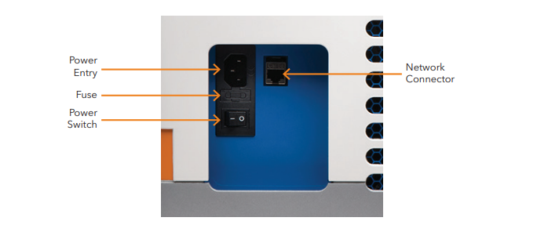

Environmental and Chemical Safety

Manage all samples and cleaning agents according to their Safety Data Sheets (SDS).

Dispose of waste cartridges, solvents, and cleaning fluids per facility waste disposal SOP.

Operational Readiness

Only Facilities Management, vendor, or a certified engineer may install a Maurice C. system

Emergency Procedures

In the event of an emergency, use the software or the button on the device to perform an emergency stop.

After stopping the device, disconnect the device from the power source.

Equipment Overview

Model: BioTechne ProteinSimple Maurice C.

Type: A system for capillary electrophoresis and icIEF processes and applications.

Control Systems: Monitoring, batch set up, and data analysis use Compass for iCE software.

The software also supports 21 CFR Part 11 compliance.

Provides the user with contemporaneous monitoring with pl calculation.

Provides tools that allow the user to visualize charge, heterogeneity analysis.

Documentation / Data Logging

Audit trails and electronic records maintained per 21 CFR Part 11.

Manual entries for calibration and maintenance documented in equipment logbook or electronic system.

Reports are generated automatically and can be exported as a PDF or a CSV.

Related Equipment, Instruments, Reagents, and Solutions

Equipment and Instruments

Associated equipment that is used for installing cartridges, preparing reagents, and preparing samples include the following:

Computer

Centrifuge

Pipettes and Pipette tips

Vortex Mixer

Reagents and Solutions

Table 5-1: Reagents and Solutions
Reagent/Solution | Description
icIEF Cartridge | Sample preparation chambers used for catholyte and anolyte solutions.
pl Markers | Provides sample pl accuracy by using proteins with isoelectric points that are known.
Electrolyte Solutions | Two types of solutions are used: anolyte as an acidic solution and catholyte as a basic solution. The electrolyte solutions assist in maintaining conductivity when running icIEF.
Deionized Water | Used for cleaning and reagent preparation, particularly of the IEF Separation mix.
IEF Separation Mix | Requires dilution with deionized water; allows for pH visibility via a gradient.
Standard for Fluorescence Calibration Standard | Allows for imaging by means for fluorescent sensitivity.

Equipment Operation

Turning on the System

Turn on the Maurice C. by pressing the power button on the front panel of the device. See Figure 5-1: Maurice C Front Panel

Figure 5-1: Maurice C. Front Panel

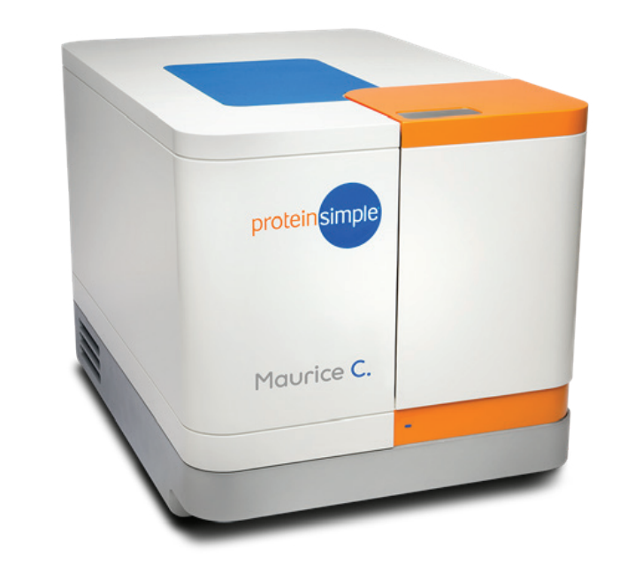

Verify that the Maurice C. and the computer are connected, then start the software.

Allow the instrument to run through its initialization checks. Once complete, the device will display “Ready.”

Sample and Reagent Preparation

If the IEF separation mix is not premixed, then mix the methyl cellulose with the ampholytes using a vortex mixer.

If the IEF separation mix is in concentrate, use deionized water to dilute according to instructions provided by the manufacturer using a vortex mixer.

Select the correct pl markers based on the anticipated range of pl for your sample.

Cartridge and Sample Preparation

Using pipettes, fill in the cartridge chambers with the appropriate electrolyte solution.

Beginning a Batch in Compass for iCE

To launch compass for iCE, open the software, log-in using your log-in username and password.

When creating a new batch, input your batch name. Select the proper cartridge type for the batch and define the parameters of your match method.

When defining the parameters of your method, select the appropriate method template or create a new method.

Confirm your plate layout and method settings using the Preview function.

When setting the focusing time, voltage profile, and mobilization parameters, refer to the laboratory SOP.

Confirm the temperature settings that are used for the capillary and sample plate.

Save the configurations used for the batch before batch execution.

Click “Run” to begin processing the batch.

For compliance, sign with an electronic signature.

Usage and Archiving Documentation

Maurice C. uses Compass for iCE software for user authentication, electronic signatures, and audit trails.

Export and store batch reports as a pdf or csv. Store files according to SOP.

Batch records may be maintained in Compass for iCE directories.

Maurice C. usage is tracked using Compass for iCE.

System User Access

Each user must have a unique username and password to maintain data integrity principles per KK-QD-128633, North Carolina Site Data Integrity Risk Assessment Process.

QC Manager approves user access to the system.

ICT creates the user account.

Administrator’s access must not be used for testing activities.

The Compass for iCE software has various levels of access. The level of access granted to each user should be the minimum access necessary to perform the user’s job function.

Analyst: allows the user to run protocols, save files.

QC Management: allows the user to modify system settings, create, modify, and delete protocols, run protocols, save files.

Reviewer: allows the user to view access to files.

Administrator (ICT): allows the user to create, modify or delete user accounts.

Back up intervals for Compass for iCE directories are established by IT in KK-QD-128633, North Carolina Site Data Integrity Risk Assessment Process.

Equipment Management

Inspection and Use Monitoring

Inspect cartridges and Compass for iCE alerts before each batch run.

Routine Maintenance

Document any maintenance or qualification activities in the equipment logbook.

To ensure optimal operation of the instrument, perform the following preventive maintenance procedures as needed:

Daily and after every run, clean the cartridge.

Check the status of the Maurice C. before every run in Compass for iCE.

Every week, check the sample plate holder for damage and cleanliness and clean it if necessary.

Every year, Facilities Management, vendor, or certified engineer services the device.

Parts Exchange

Cartridges must be replaced after one hundred (100) injections.

Calibration

Each batch is calibrated to the fluorescence standard automatically during batch setup.

Periodic Validation

Verify the performance of the device by running peptide panels.

Utilize the suitability test established in KK-QD-#######: SOP Title [Suitability Testing]

Statutory Inspection

N/A

Time Synchronization

N/A

Handling of Abnormal Situations

Cartridge Expiration

Cartridge errors may occur due to an RFID tag not being detected or the cartridge having expired.

To troubleshoot, replace the cartridge with a new one and verify that it was properly installed.

Failure when Injecting Samples

Sample injections may fail due to the presence of bubbles or the plate not being loaded correctly.

To resolve this issue, reprepare the sample and reload the plate.

Emergency Stop

There are two ways to perform an emergency stop on the Maurice C: software stop and hardware stop.

To perform a software emergency stop during a batch run, click “Stop” in the software. See Figure 5-2: Software Emergency Stop Prompt

Figure 5-2: Software Emergency Stop Prompt
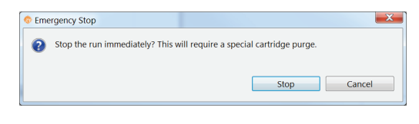

To perform a hardware emergency stop, press the power button.

Error Recovery

After aborting runs, use the purge cycle to clean and clear capillaries. See Figure 5-3: Purge Prompt and Error Notification

Figure 5-3: Purge Prompt and Error Notification

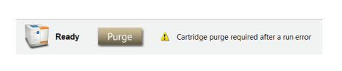

Contact BioTechne technical support if errors persist.

ASSOCIATED FORMS AND TEMPLATES:

N/A

REFERENCES:

KK-QD-#######: SOP Title [Suitability Testing]

KK-QD-128633: North Carolina Site Data Integrity Risk Assessment Process.

Anton Paar DMA 4501 Densitometer Instruction Manual

21 CFR Part 211

ATTACHMENTS:
N/A

VERSION HISTORY:

Version | Date of Approval | Description of Change
1.0 | List document approval date or reference Vault Quality Documents (VQD) for approval date. | Change Justification:  Include Document Change Control (DCC) number.  Description of Change:  Include brief description of changes made within the corresponding document version.

Attachment 1: Title

